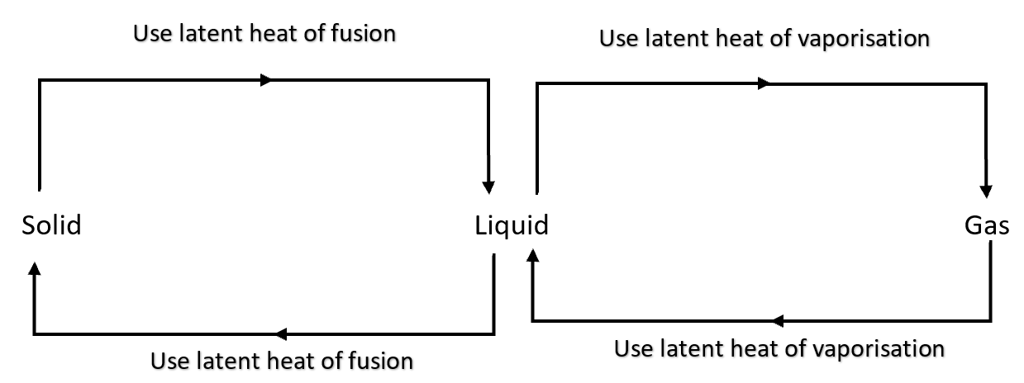

Light-coloured/reflective objects are good at reflecting radiation and bad at emitting radiation. They won’t heat up as quickly under the Sun and won’t cool down as quickly.

Dark-coloured/unreflective objects are good at absorbing radiation and good at emitting radiation. They’ll heat up more quickly under the Sun and will cool down more quickly.

Impurities will reduce the freezing point of water.

Properties of materials which change in temperature:

1. Electrical resistance.
2. Voltage generated at junction between 2 metals.
3. Expansion.

Q: Using kinetic theory, explain what’s happening to the ice over the whole graph.

T

90

30

t (s)

0–30s: As the ice gains energy, it **gains both potential and kinetic energy**. The gain in **potential energy stretches the bonds**, causing thermal expansion, and the gain in **kinetic energy makes particles vibrate more quickly, increasing temperature**.

30–90s: The gained energy all becomes **potential energy**, **breaking bonds** as the substance changes phase. **No kinetic energy** is gained so there’s **no increase in temperature**.

Q: **Explain why steaming cooks faster than boiling.**

**Steam has more energy than water at the same temperature because it contains the **latent heat of vaporisation** in addition to the energy held due to its temperature. In contact with food, the steam has **more energy to transfer to the food**.**

**Q: On a warm sunny day, the Sun’s radiation melts very little snow on the slopes of an alpine ski resort. Why?**

**The snow is a reflective white colour, **reflecting** most of the solar radiation. It **only absorbs a small amount of energy** leading to only a **small amount of melting**.**

**Q: Why does a foot in a wet sock usually feel colder than a foot in a dry sock even if both socks have the same temperature?**

**A foot in a dry sock is **insulated by trapped pockets of air** in the sock while a foot in a wet sock can easily **lose heat to the water by conduction**. The loss of heat is responsible for the feeling of being cold.**

**OR**

**As air moves over the wet sock, it causes the water to evaporate, **absorbing energy from its surroundings as latent heat of vaporisation**. This energy largely **comes from your foot**, resulting in the cooler sensation. The dry sock contains **trapped pockets of air** which **insulate** your foot, **preventing heat loss by conduction and convection**, causing your foot to feel warmer.**

Q: **In hot weather, it isn’t uncommon for pet dogs to stretch out on a tiled floor. Why do they choose a tiled floor rather than other surfaces?**

**The tile floor is a **better conductor** than a carpet floor. The dog will **more quickly lose energy** to the tile floor, allowing it to cool down faster.**

**Q: Using kinetic theory, explain why:**

**a. The pressure increases when more air is put into a car tyre.**

**The particles in the tyre are **closer together** and **more tightly packed** so the **rate of collisions** with the walls of the tyre will **increase**.**

**b. It is dangerous to put an aerosol can on a fire.**

**The particles inside will **gain a lot of kinetic energy**, **increasing their speed**, and thus **how often and forcefully they collide** with the walls of the can. This will **increase the internal pressure** until it **exceeds what the can is capable of resisting** and so it will burst violently.**

c. **A lady’s perfume can be detected at some distance from her, even when there are no draughts.**

**Gas particles move randomly in straight lines. A wind would be needed to carry all the perfume particles as a group, but **individual particles can quickly spread out over large areas**. For strong perfumes it doesn’t take a large concentration to be able to smell them.**

Q: **Why do solids not increase in temperature while they are melting even though heat energy continues to be supplied?**

**During a phase change, **all added energy is becoming potential energy** in **stretching** and then **breaking** the bonds. There’s **no gain in kinetic energy** so there’s **no increase in temperature**.**

**Q: What’s wind chill?**

**As wind blows across your body there are **collisions between air particles and the particles of your body**.**

Q: **Water is a good absorber of radiated heat energy. Why, then, does it not get hot very quickly?**

**Water has a very high specific heat capacity, so it requires **large quantities of energy to change in temperature significantly**. Another substance that is less good at absorbing radiation may still heat more quickly if it has a much lower specific heat capacity.**

**Q: Explain why**

**a. Telephone wires are left slack when hung between poles.**

**In cold weather the wires will contract, shortening. There needs to be **enough length to still span the distance when cold**.**

b. **Concrete roads have bitumen-filled gaps across them.**

**The concrete will expand when weather is hot. The gaps **allow room for it to expand into** without damaging itself.**

c. **Steel can be used to reinforce concrete.**

**Concrete and steel **expand at the same rate** so they can be mixed without one breaking the other due to expansion or contraction.**

**Q: Explain why:**

**a. An aluminium window frame feels cold when you touch it, but a wooden frame feels warmer.**

**Aluminium is a **good conductor** of heat and will be cooler than human body temperature. This means that **energy will flow rapidly from your body to the aluminium**. This is felt as a cold sensation. The wood will also be cooler than your temperature but is a **poor conductor** so **energy will only very slowly flow from your body to the wood** so it will feel much less cold.**

b. **Aerated concrete is a better insulator than normal concrete.**

**The trapped air bubbles in the aerated concrete contain gas, which is a very poor conductor, much worse than the concrete itself. This is because the particles are **much more spread out in the gas** and are only **weakly connected to each other**. This leads to a **reduction of the conductivity of the air-concrete mixture** overall.**

Q: **Ibrahim feels a draught when the bonfire burns fiercely. Why?**

**The bonfire causes the **air around it to expand**, becoming **less dense** and therefore **rising**. This leads to an **updraft** over the bonfire. The updraft causes **low air pressure around the fire** so **air from around the outside is drawn inwards** towards the fire, creating a draught.**

**Q: Explain why:**

**a. If you tip methylated spirits on the back of your hand, the methylated spirit vanishes, and your hand feels cold.**

**Methylated spirits are **volatile** (evaporates very easily) so it rapidly **evaporates**, **absorbing the latent heat of vaporization from your hand** and cooling it.**

b. **On a humid day, you feel hot and uncomfortable.**

**If there is more water already in the air your **sweat takes much longer to evaporate**. With less of your sweat evaporating **you aren’t losing as much energy to the latent heat of vaporisation**, so your **sweat isn’t effectively cooling you** and you feel too hot.**

Q: **Explain how the breeze can cause a cooling effect on a person.**

**As air movement encourages evaporation, the breeze **causes your sweat to evaporate more quickly**, **absorbing the latent heat of vaporization more quickly**, cooling you.**

**Q: Draw a heating curve and give a detailed explanation of the curve as heat is applied.**

**As the solid is heated it **gains kinetic energy** causing the **particles to vibrate faster**, **raising temperature**. It also **gains potential energy** causing the particles to **stretch** further apart, causing the substance to **expand**.**

**As the substance melts it **doesn’t gain kinetic energy**, so the **temperature does not change**. It does **gain potential energy** causing the particles to **stretch** and then **break their bonds** as they change phase.**

**As the liquid is heated it **gains kinetic energy** causing the particles to **vibrate faster**, **raising temperature**. It also **gains potential energy** causing the particles to **stretch** further apart, causing the substance to **expand**.**

**As the substance boils it **doesn’t gain kinetic energy**, so the **temperature doesn’t change**. It does **gain potential energy** causing the particles to **stretch** and then **break their bonds** as they change phase.**

**As the gas is heated it **gains kinetic energy** causing the particles to **vibrate faster**, **raising temperature**. It also **gains potential energy** causing the particles to **stretch** further apart, causing the substance to **expand**.**

Q: **Why does the brass handle of the door feel colder than the wooden door itself when you touch them even though they are the same temperature?**

**Brass is a **good conductor** of heat and will be cooler than human body temperature. This means that **energy will flow rapidly from your body to the brass**. This is felt as a cold sensation. The wood will also be cooler than your temperature but is a **poor conductor** so **energy will only very slowly flow from your body to the wood** so it will fell much less cold.**

Q: **Explain why steam gives a more severe burn than boiling water.**

**Steam at 100°C contains more energy than water at 100 °C. This is because steam **contains the latent heat of vaporization** while water does not. When contacted by hot water or steam, it will cool, **releasing its energy** to you which causes the burn. The **steam has more energy to release** so it will cause more severe burns.**

**Q: How does a fridge work?**

**Coolant, compression and expansion, latent heat, removes heat from the inside and puts it outside.**